IB Film Chase Scene Commentary – Sound Designer

The Chase Scene project is an assessment that emphasizes on editing skills and using that as a basis to present the craft of continuity editing. It can also incorporate aspects of montage editing to provide an abstract feeling to the video that can be evident through transitions and composition. A narrative should be commenced to convey a clear understanding of how the plot is developed and why narrative causation plays a major role in the production of a chase scene through Barthes enigma code and equilibrium structures of equilibrium, disequilibrium and new equilibrium in reference to Todorov’s Three Act Structure. There are other elements of comedy, thriller and suspense, which are definitely included in addition with the narrative to provide engagement for the audience. Over the duration of the project, I have been working with my classmates Christopher and Luca who were the cinematographer and editor of the Chase Scene. My role in this project was being a sound designer, which meant that I had the responsibility of recording different types of sound when the scene is being filmed, editing the levels using Audacity and layering my captured sound by making a soundtrack for the video.
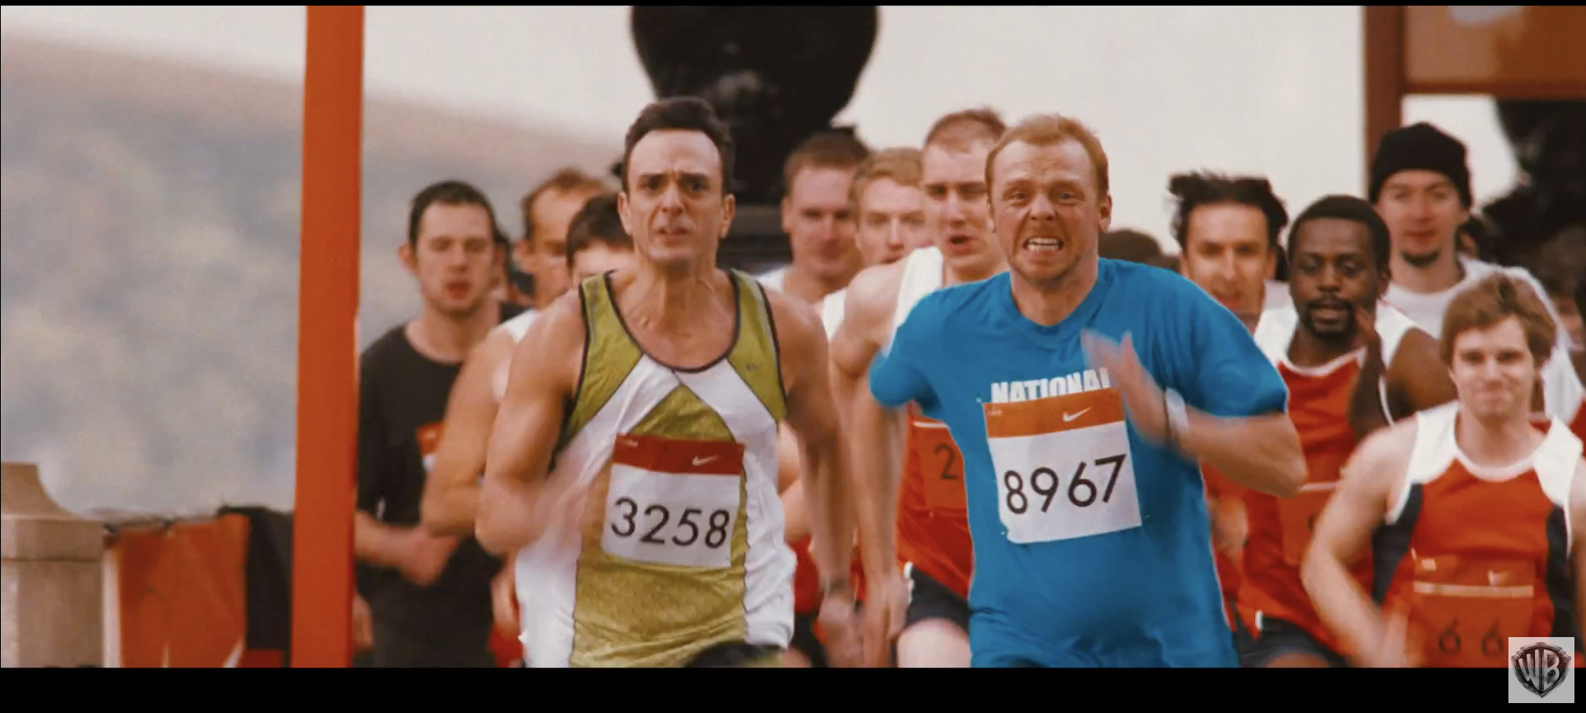
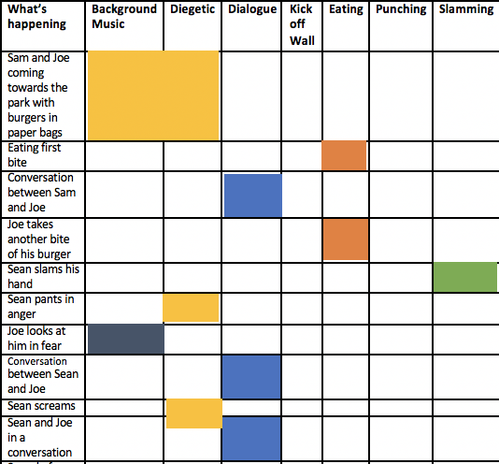
As a group, we had decided to use the film Run Fatboy Run (Schwimmer, 2007) as an inspiration to produce our chase scene because it has a comedic aspect to the film, which we wanted to capture. Run Fatboy Run which is about Dennis Doyle (Simon Pegg) who elopes on his wedding day when his wife was pregnant and several years later his son enrolls in a marathon race. Doyle decides to participate in order to prove his worthiness of being a father to his son. This implies the commencement of a newly built interest to his own lifestyle. I watched several scenes of the film and its trailer in order to understand the style I wanted to recreate. My filmmaker intentions were to adopt some of the sound types used in Run Fatboy Run which includes foley, ambient sound and sound layering of instruments. When the drums were played at the background in contrast with the layer of dialogue. The instrumental music is of fast pace as the sound tempo increases when Doyle is running rapidly. It was edited through using Audacity to layer the sound and reduce slightly high noise levels that the camera sound taken.

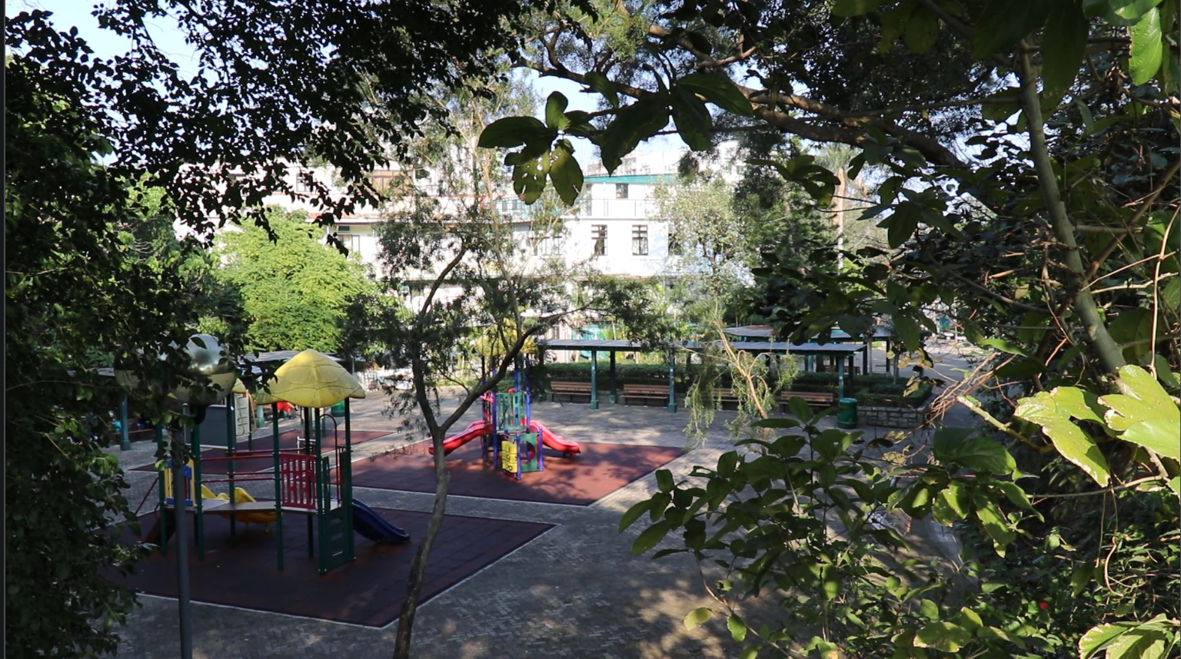
As a sound designer, my role was to think of what type of sound will best suit the video that would be convenient for me to compose. I made a production schedule for our group members to be familiar with the organization of the project such as dates for filming and deadlines. In terms of pre-production, I produced a dubchart that highlights the stages of planning of what sources of sound should be included in the Chase Scene to outline at what scenes would I be able to. I thought that using ambient sound at the beginning of my video when the setting of the playground is introduced. When filming at Sai Kung Old Town Playground, I recorded the sound of the environment around me for ambience to suggest presence in the background. A distinct feature of ambient sound included was birds chirping. I had also recorded the dialogue between both characters Joe and Sean by placing myself at a close distance to them without any movement of the sound recorder, therefore clarity in sound is ensured. For additional sound effects, I used several foley techniques such as recording the sound of myself kicking a cupboard as I locked my room door and ensured that the windows were closed in order to maintain clarity. This correlates with my film in the fight scene where Joe demonstrates his martial arts techniques by doing a side kick. Another example of foley sound was when I recorded Joe saying ‘Hiya!!’ as he commences the fight scene and brings a comedic element to the film.

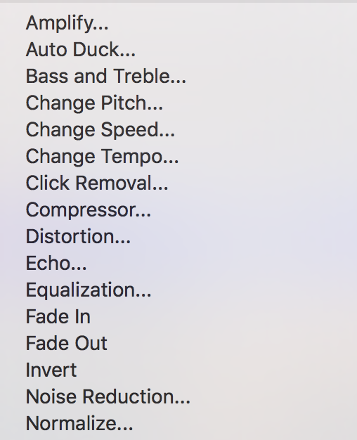
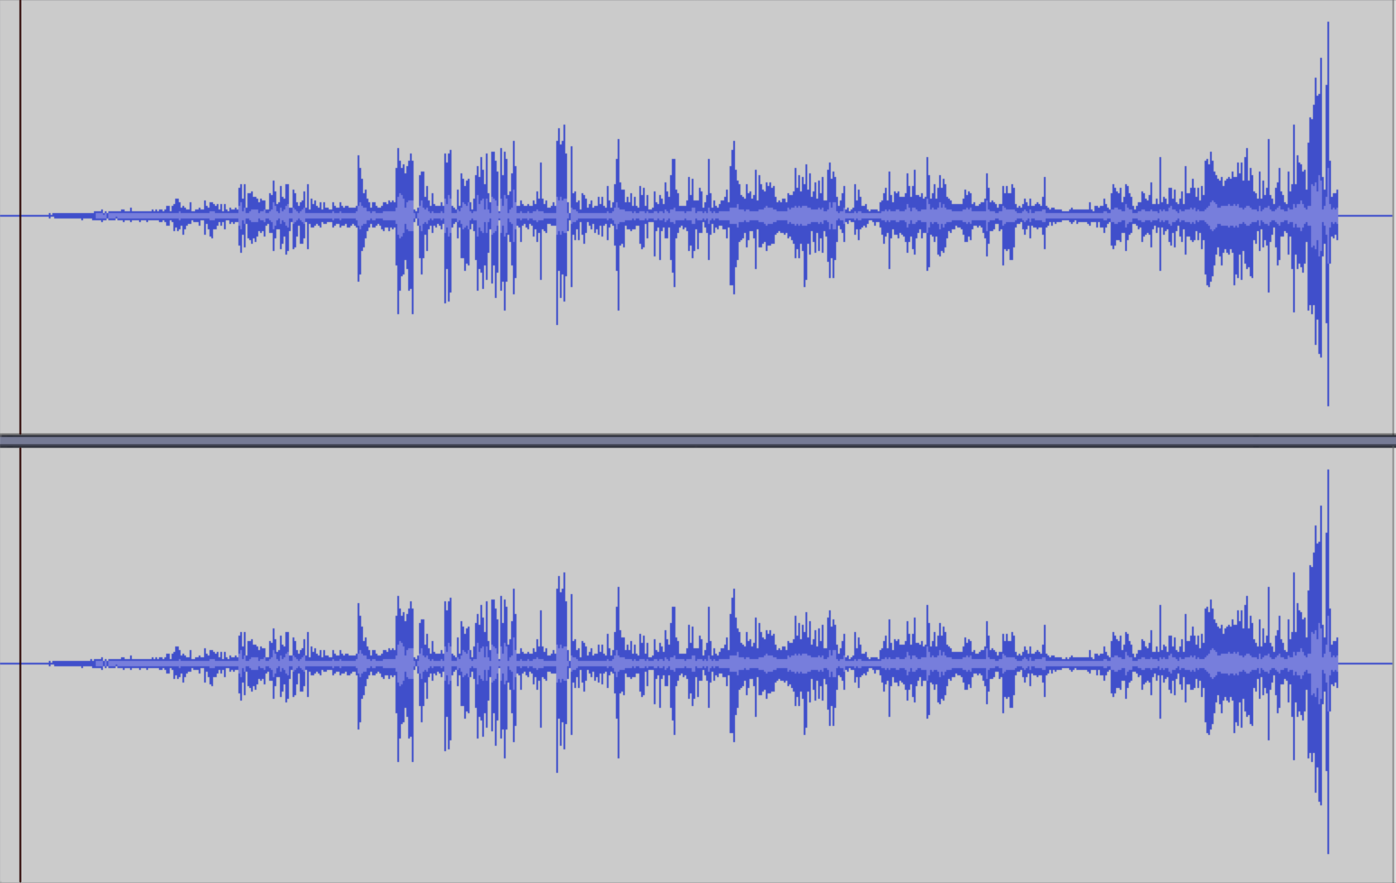
I used Camtasia 3 to merge the sound recordings together as Luca (Editor) had experience using the editing software, therefore he had recommended me to continue with the same piece of software due to convenience. In Camtasia 3, different audio points can be selected where at a certain point the sound level can change. At the start of the Chase Scene, I used Audacity to select areas with high levels of sound, normalize and amplify it. The sound waves would decrease and remove any excess levels of sound in order for it to balance out. I learned that there are a wide variety of functions that can be utilized for sound editing on Audacity especially the amplify, noise reduction and normalize functions. However, as I was not very organized in terms of my time management skills because Garageband would enable me to experiment with instrumental sound.

Overall, I have fulfilled my role as a sound designer to a satisfactory standard as I have been able to demonstrate that I am able to use the basics of sound editing. I felt that my role involved a passive approach as a sound designer because during the filming process I had only recorded sound and failed thoroughly experiment with it. In future projects, I have learnt that organization is fundamental from start until the project finishes. Garageband should have been the basis of my sound track composition to demonstrate an understanding of my filmmaker intentions.

Word Count: 897 words

References:

“Run Fatboy, Run.” IMDb , IMDb.com, Retreived 14 March 2018 from http://www.imdb.com/title/tt0425413/

Ryan, K, IB Chase Scene, KGV Film and Media, Retrieved from: https://www.kgvmedia.com/ib-chase-scene

